Cagianut & Company CPA
Accounting Seminar for Managers
Friday, June 7, 2013
1:00 – 3:30pm
Bellevue – Embassy Suites

Off to the
Races!

Agenda
- Welcome – Gayle (1:00 –1:10)

- Going Electronic: Moving Away from Paper - Panel (1:10 – 1:30)
  - Panel discussion from those who are doing it! Pro’s and Con’s. What works and what doesn’t ~
- What hardware/software are they using?
- What items are they scanning now?
- What percentage of an Association’s records are electronic now?
- Do they have plans to scan more items later? (If not 100% electronic)
- Do they shred the original after scanning?
- Who has access to these scanned documents?
  - Is it limited based on the type of document? If so, how do they handle security, etc?
- What tips do they have?

  - Questions from the audience.

- Audit & Reserve Studies - Gayle (1:30 – 1:45)
  - Washington RCW disclosure requirements
  - RSI (Required Supplementary Information) – Why auditors ask the questions we ask
    - Changes between reserve studies – be able to explain the reasons for the changes
    - “Accepted” reserve studies as RSI

- Special Assessments & Loans - Panel/Gayle (1:45 – 2:15)
  - What are the pitfalls and traps to avoid when considering special assessments…especially those tied to loans?
  - What to know BEFORE you start the process and what you need to have in place DURING the time it is ongoing.
(There is separate handout for this section of the presentation)

- Audits - Gayle (2:15 – 2:30)
  - What were key areas this year?
    - Sheriff’s Sales
    - Controls on other income (e.g. Move In/Out Fees, Guest Suite, Transfer Fees)
  - Look at the audit process from a “best practices” viewpoint. How can you use the audit to improve your accounting processes and protect your association’s assets?
    - Best Practice handout
    - Tips handout
    - Using the Report of Internal Control as a tool

- B&O Taxes - Mark Hugh (2:30 – 3:30 )
  - What are the hidden landmines for associations??

RCW 64.34.308 (New Act Condos) Note: Old Act Condos have no similar requirement

(3) Within thirty days after adoption of any proposed budget for the condominium, the board of directors shall provide a summary of the budget to all the unit owners …
(4) As part of the summary of the budget provided to all unit owners, the board of directors shall disclose to the unit owners:
(a) The current amount of regular assessments budgeted for contribution to the reserve account, the recommended contribution rate from the reserve study, and the funding plan upon which the recommended contribution rate is based;
(b) If additional regular or special assessments are scheduled to be imposed, the date the assessments are due, the amount of the assessments per each unit per month or year, and the purpose of the assessments;
(c) Based upon the most recent reserve study and other information, whether currently projected reserve account balances will be sufficient at the end of each year to meet the association's obligation for major maintenance, repair, or replacement of reserve components during the next thirty years;
(d) If reserve account balances are not projected to be sufficient, what additional assessments may be necessary to ensure that sufficient reserve account funds will be available each year during the next thirty years, the approximate dates assessments may be due, and the amount of the assessments per unit per month or year;
(e) The estimated amount recommended in the reserve account at the end of the current fiscal year based on the most recent reserve study, the projected reserve account cash balance at the end of the current fiscal year, and the percent funded at the date of the latest reserve study;
(f) The estimated amount recommended in the reserve account based upon the most recent reserve study at the end of each of the next five budget years, the projected reserve account cash balance in each of those years, and the projected percent funded for each of those years; and
(g) If the funding plan approved by the association is implemented, the projected reserve account cash balance in each of the next five budget years and the percent funded for each of those years.

RCW 64.38.025 (Homeowners Associations)

(3) Within thirty days after adoption by the board of directors of any proposed regular or special budget of the association, the board shall set a date for a meeting of the owners to consider ratification of the budget not less than fourteen nor more than sixty days after mailing of the summary…
(4) As part of the summary of the budget provided to all owners, the board of directors shall disclose to the owners:
(a) The current amount of regular assessments budgeted for contribution to the reserve account, the recommended contribution rate from the reserve study, and the funding plan upon which the recommended contribution rate is based;
(b) If additional regular or special assessments are scheduled to be imposed, the date the assessments are due, the amount of the assessments per each owner per month or year, and the purpose of the assessments;
(c) Based upon the most recent reserve study and other information, whether currently projected reserve account balances will be sufficient at the end of each year to meet the association's obligation for major maintenance, repair, or replacement of reserve components during the next thirty years;
(d) If reserve account balances are not projected to be sufficient, what additional assessments may be necessary to ensure that sufficient reserve account funds will be available each year during the next thirty years, the approximate dates assessments may be due, and the amount of the assessments per owner per month or year;
(e) The estimated amount recommended in the reserve account at the end of the current fiscal year based on the most recent reserve study, the projected reserve account cash balance at the end of the current fiscal year, and the percent funded at the date of the latest reserve study;
(f) The estimated amount recommended in the reserve account based upon the most recent reserve study at the end of each of the next five budget years, the projected reserve account cash balance in each of those years, and the projected percent funded for each of those years; and
(g) If the funding plan approved by the association is implemented, the projected reserve account cash balance in each of the next five budget years and the percent funded for each of those years.

RCW 64.38.090 Reserve study — Exemptions (HOAs)
An association is not required to follow the reserve study requirements under RCW 64.38.025 and RCW 64.38.065 through 64.38.085 if the cost of the reserve study exceeds five percent of the association's annual budget, the association does not have significant assets, or there are ten or fewer homes in the association.
RCW 64.38.010 (19) "Significant assets" means that the current replacement value of the major reserve components is seventy-five percent or more of the gross budget of the association, excluding the association's reserve account funds.

SAMPLE RESERVE DISCLOSURE

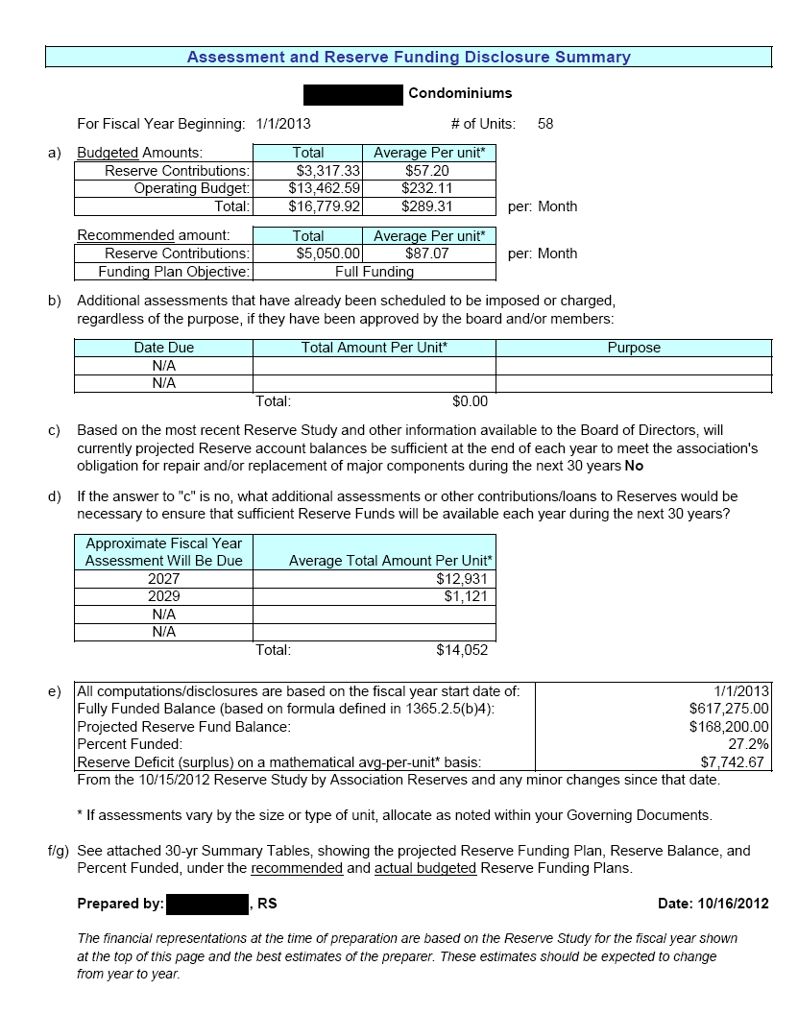

REQUIRED SUPPLEMENTARY INFORMATION (RESERVE STUDY)
SAS 120 – Audit Standard effective for year ends beginning 12/31/11
Should = Mandatory
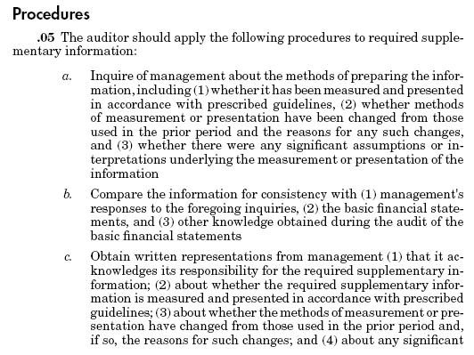
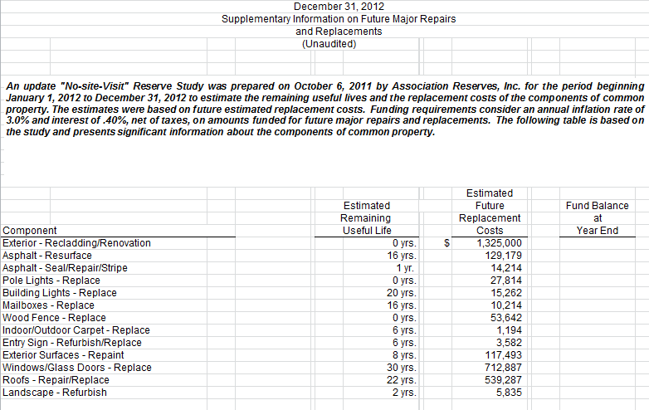
Sample RSI – Last page of audit report
SHERIFF’S SALES
(The following is taken from a presentation that I did for the California Society of CPAs in 2011)
Foreclosures
This section of the CIRA Conference deals with when an Association takes back a unit in foreclosure. We will not deal with the legal details about how that occurs, but instead discuss potential accounting, auditing and tax issues.
Caveat from the beginning – there is not a lot of written documentation on this subject either by the accounting authorities or by the Internal Revenue Service. Each accountant must take the information as presented, do their own due diligence and decide how to handle their particular situation.
Basic scenario ~
- The lender is slow to foreclose on a unit within the Association
- Association forecloses – the lender does not bid
- The Association is awarded title of the property
- Unit is still subject to loan
- The unit loan exceeds the value of the property
- At some point in the future the bank/mortgage company will foreclose and take possession of the unit
We will use this simple situation to base our discussion. But there are always exceptions. Here are a few:
- An association that took back a unit in foreclosure where the unit owner continued to make mortgage payments for a period of time.
- Several associations that took back a unit, fixed it up, and sold it at a profit.
- A couple of associations where the bank did not perfect their lien in the required time (Washington State) and instead of going before a judge to assert their mortgage position, they paid the associations $10,000 to $20,000 to release the unit.
- The Association is in the process of a quiet title action against the lenders to confirm that clear title is vested in the Association as the lenders missed their redemption period. (Ongoing – not resolved.)
- The IRS had a tax lien on the unit and the IRS paid the Association ½ of the Special Assessment in negotiations in order to speed up escrow.

Recording the Asset on the Financial Statements
(References included herein are from FASB Codification)
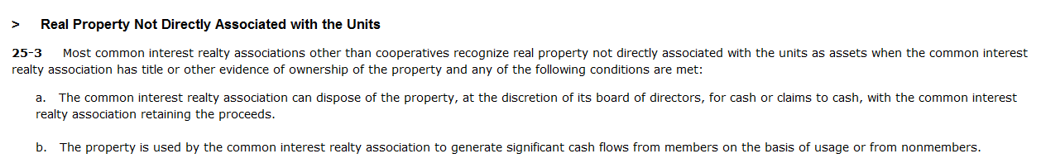
It is clear that the Association has taken title of the unit. Generally, it is clear that the Board can dispose of the property.
The loan cannot be recorded on the Association’s financial statements because the Association is not obligated to pay those loans.

Some guidance indicates that the Fair Value (less costs) should be recorded at the time of foreclosure and a gain recorded between that value and the value of delinquent assessments. However, that guidance does not seem to consider impairment of the asset.

We are to test an asset for recoverability by comparing its estimated future cash flows with its carrying value. The asset is not recoverable when the future cash flows are less than the carrying amount. The estimated cash flows must include future flows directly associated with the use of the unit and eventual disposal of the asset.

Thus, it is my assertion that the carrying value as adjusted for impairment is usually zero. Some believe that the amount of the receivable should be the value of the asset. This would be true if there was a probability of collection of that receivable. Otherwise, it seems to me that receivable would require an allowance for bad debt. Often the client wants to keep the asset on the books showing the receivable balance and any other costs. That seems reasonable to me; however, I also may set up an allowance to offset that balance.

Disclosures
Sample Disclosures (Specific to Washington Law)
The Association obtained title to Unit 101 on February 2, 2011 in a Sheriff’s Sale (judicial foreclosure) for the amount of the past due assessments and other costs. While the Association does have title to the unit, the original owner has a one-year redemption period to reclaim the property for the amount paid by the Association. In addition, the current mortgage on the unit exceeds the estimated fair market value of the unit. Thus, management has determined that the asset has no value and it has not been included on the financial statements of the Association. The Association has no legal responsibility with regards to the mortgage holder except what may be required under the law if rents are collected as the Association did not assume the loan. The Board has obtained legal counsel for advice about future actions with regards to this property. No outcome can be determined at this time.
The Association foreclosed on a unit December 10, 2010. The property is subject to a mortgage that exceeds the fair market value of the property. The future cash flows from the eventual disposal of this unit will not result in any monies due to the Association except for the six months of assessments as allowed under Washington Law. Thus, the asset is impaired and the carrying value on the books of the Association is zero.
************************************
Audit Procedures and Checklists
- Obtain sale or escrow document (some sort of proof of sale) when unit was obtained
- Verify receipt of any monies received
- Inquire as to any redemption period
- Inquire as to whether there has been any correspondence from the bank/mortgage company
- Record outstanding receivable on foreclosed unit and any allowance for bad debts
- Determine if the asset is impaired and whether there is any future cash flow value to the Association
- Inquire of Association as to whether there was a legal opinion on the matter
- Inquire as to the Association’s plans for the unit
  - If Rental
    - Is there a legal opinion on this?
    - Has the Association obtained the proper insurances?
    - Has the Association captured the Rental Income and Expenses in separate account categories?
- Determine if unit was sold by the end of the year or by the audit report date.
  - If so, compute gain/loss – if any
  - Disclose sale as current or subsequent event
OTHER INCOME – MOVE IN/OUT FEES, GUEST SUITE USAGE, TRANSFER FEES)

We are looking for completeness…how do you really know that you have captured all of the income?? Think of the various ways that the money either might not be collected or might not be transferred to the Association (MATERIAL dollar amounts) ~ Seriously… take some time and think of everything that COULD go wrong with the association you manage.

What does NOT work:

- The onsite manager puts events/guest suite usage on the calendar and then sends the calendar and the money to accounting

- The concierge makes a list of the guest suite monies collected and sends the money with the list to accounting at the management company

- The Association deposits only what the escrow company sends to them

Look to procedures that allow an independent analysis and/or another party to be involved:

- A separate calendar is kept of usage & an independent person periodically checks the calendar against actual usage.

- An expense that is directly associated with the income is compared – e.g. housekeeping/guest suite; janitorial/clubhouse use; new pool key/change of owner/tenant.

- Tenant logs/contracts are compared against move in fees.

- An independent outside source or service is used to determine when there is a change in ownership.

- The Board is told to be alert for signs of new owners/tenants and makes note of move-ins. The management company/manager puts the number of Move In/Out fees in the agenda. These are compared.

- The Board randomly checks when a guest suite is being used or the clubhouse has an event. At the end of the month, they verify that there was a corresponding deposit for that date.

Look at the audit process from a “best practices” viewpoint. How can you use the audit to improve your accounting processes and protect your association’s assets?

The Report of Internal Control is a required document. Whenever we find errors, prepare adjusting journal entries or note weaknesses in a system, we are required to document such and send with the audit. Use this as management tool. Don’t hide or ignore it! Don’t worry, you are not the only Association/management company getting these from us.

(Caveat – in prior years there was only a management letter and it was optional – see #2 in Tips Brochure. Management letters are still an option, for items that don’t rise to the level of an Internal Control point.)

The top IC comments this year ~

- Lack of compliance with Washington RCW regarding reserve disclosure requirement (discussed earlier)

- Over FDIC as of 1/1/13
  - As of 1/1/13 the FDIC limit went back to $250,000. Many associations did not adjust the cash balances.
  - Check the Association governing documents! Many of these documents required funds to be federally insured. Even if the governing documents don’t, it is industry standard to protect the principal.
  - Have an investment policy. (See #6 in Tips Brochure) This will document when, if ever, it is appropriate to invest in non-FDIC or non-government insured products.

- Reserve expenses are not approved in the Board meeting minutes. (See #5 in Tips Brochure)
  - There are more strict compliance matters with regards to the use of reserve monies; thus, knowing the Board approved the use and it is documented in the minutes is a good corporate record.
  - At times there is some subjectivity with regards to when an expense is operating or reserve expense. Thus, this ensures proper classification of the expense.

- Bad debt write-offs are not approved in the minutes.
  - It is possible for fraud or error to occur with regards to bad debt write-offs. Thus, the Board should be aware when an asset is written off – even when being advised to do so by an attorney or collection agency.

- Lack of controls on other income (discussed previously)

