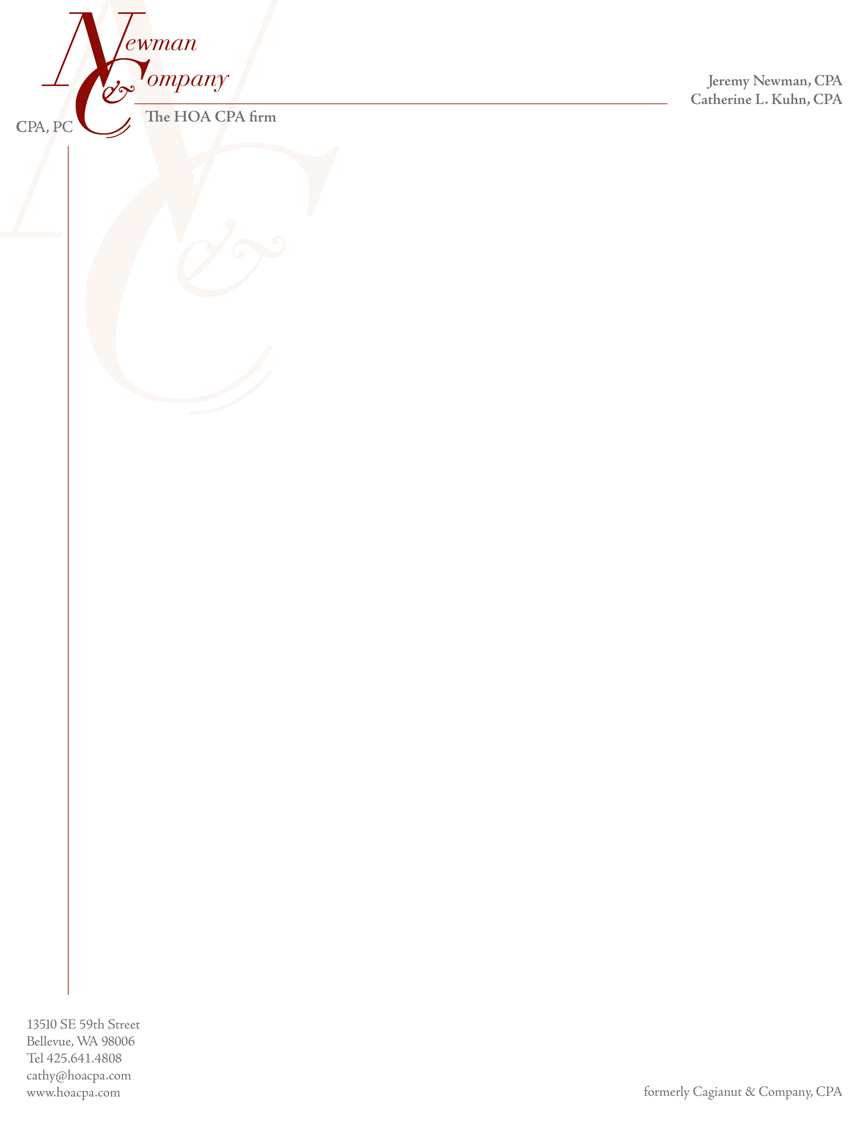

Accounting Manager, CFO, Treasurer or Person Responsible for Financial Statements of the Association:

As is industry standard and usually required under the Revised Code of Washington (RCW), the year-end financial statements are prepared using generally accepted accounting principles (GAAP). We, as auditors, agree that this is an appropriate and acceptable financial reporting framework. We, as part of the audit engagement, assist the Association in preparing the financial statements, including footnotes, which accompany our audit report. We also usually prepare the tax returns for the Association. In our engagement letter, we outline those additional services and the fact that the client accepts its responsibilities with regards to financial statements and tax returns. These services are considered to be “non-attest” type of services and we need to maintain our independence in order to audit the Association.

Thus, we need to document for our files that there is someone who can evaluate our services and who accepts responsibility for the financial statements and tax return. That person understands generally accepted accounting principles and will review and approve the year-end financial statements before they are issued. We realize that non-CPAs may not be completely sure of the disclosure requirements. A copy of a standard disclosure checklist is available on our website for your use and review.

As part of your responsibilities it is also up to you to:

* Communicate the importance of ethical behavior and appropriate business practices to your staff and boards of directors.
* Implement programs and controls to detect and deter fraud.
* Determine the susceptibility to fraud.
* Comply with Federal and State statutes, local ordinances and/or contracts, and provide us with copies of any correspondence received from relevant licensing or regulatory authorities.

Please have the person responsible for this process sign and return this letter. This year we are also asking for brief background information based on auditing standards and input from the peer review process.

We need this letter signed by _______ 2018. If this is a management company (rather than an on-site manager or self-managed association), one form will suffice for all the associations you manage.

*****************************************************************************************************************

*The person noted below, upon receipt of the draft audit report, will review the financial statements, including the footnotes, and ensure that they are in compliance with generally accepted accounting principles, including full disclosures, as required. Additionally, the person noted below accepts responsibility for the tax return or is responsible for notifying the Board of their acceptance of the tax return when signed by an Association Officer.*

By ___________________________________________ Date ____________________________

(Electronic Signature Allowed)

Printed Name __________________________________ Title_____________________________

Management Company/Association________________________________________________

Briefly explain your background to support your ability to perform the above tasks (e.g. education, experience, certifications, etc.)

_________________________________________________________________________________________________________________________________________________________________________________________________________________________________________________________

*This acceptance of responsibility will continue until revoked by the person signing the form or upon notification that this person no longer is in the same position with the Association or Management Company. This will be verified approximately every 3 years.*