FUN**d**

Things in Accounting & Auditing

(Part 2)

**C:\Users\Gayle\AppData\Local\Microsoft\Windows\Temporary Internet Files\Content.IE5\1JDDSMBC\MC900250057[1].wmf**

**Managers Only Day**

**June 14, 2012**

**Presented by Gayle L. Cagianut, CPA**

**Cagianut & Company, CPA**

**C:\Users\Gayle\AppData\Local\Microsoft\Windows\Temporary Internet Files\Content.IE5\03Z8Z2KZ\MC900198791[1].wmfWork your magic (making those numbers right) ~**

**C:\Users\Gayle\AppData\Local\Microsoft\Windows\Temporary Internet Files\Content.IE5\03Z8Z2KZ\MC900331555[1].wmf**

**Keep the books in balance**

**C:\Users\Gayle\AppData\Local\Microsoft\Windows\Temporary Internet Files\Content.IE5\1JDDSMBC\MC900233691[1].wmf**

**Tame the lions ~ who could be homeowners,**

**managers or auditors (to name a few)**

**Jump through hoops for all!**

C:\Users\Gayle\AppData\Local\Microsoft\Windows\Temporary Internet Files\Content.IE5\03Z8Z2KZ\MC900287577[1].wmf

**Juggle an infinite number of jobs ~**

**C:\Users\Gayle\AppData\Local\Microsoft\Windows\Temporary Internet Files\Content.IE5\R936G207\MC900331546[1].wmf**

**Walk a tightrope between spending**

**too much time getting it right**

**and getting it out the door ~**

**Who said the CIRCUS is the most fun around???**

C:\Users\Gayle\AppData\Local\Microsoft\Windows\Temporary Internet Files\Content.IE5\1JDDSMBC\MC900360866[1].wmf

**Accounting for Associations is Entertainment Enough!!!**

Resources for you to use:

[www.hoacpa.com](http://www.hoacpa.com)

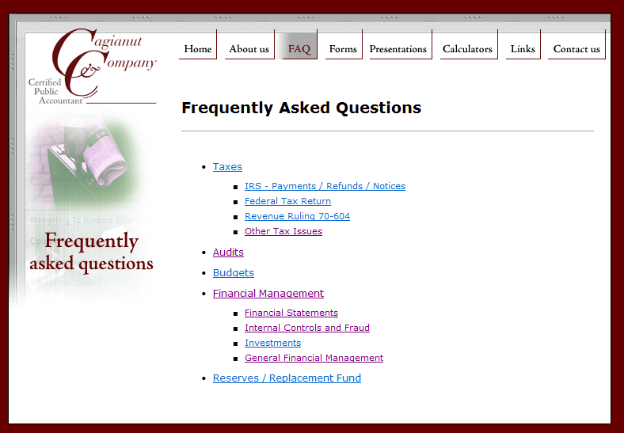

This presentation will also be on the website.

<http://cirawiki.aicpa.org/> Free site

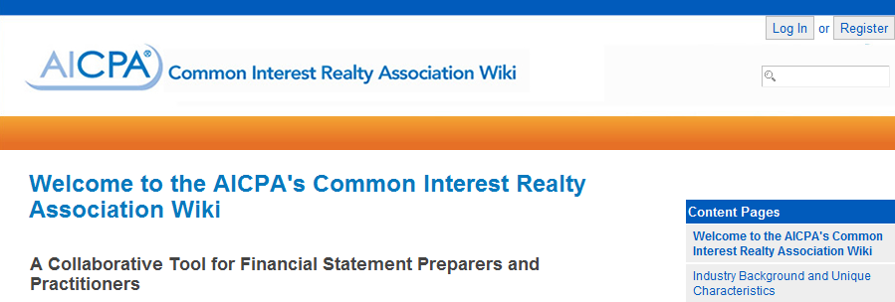

<http://asc.fasb.org/home> Basic view is Free - GAAP

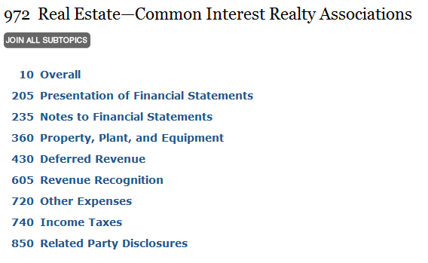

**Reserves And**

**Fund Accounting**

Reserves and the use (or lack thereof) of fund accounting is the most diverse area of accounting between the various management companies, self-managed or onsite-managed associations. It is also the most misunderstood area of accounting by even the most financially astute readers of the financial statements. When talking about “Reserves, there are four distinct areas of guidance to consider (and it is a balancing act!)~

* **GAAP – Generally accepted accounting principles as defined by FASB**
* **RCW – Washington law for condominiums and HOAs**
* **IRS – Internal Revenue Service rulings and guidance**
* **Industry Standards – Prevalent industry practices that are commonly held to be accepted**

**C:\Users\Gayle\AppData\Local\Microsoft\Windows\Temporary Internet Files\Content.IE5\1JDDSMBC\MC900250057[1].wmfGAAP**

The following are excerpts from FASB regarding Common Interest Realty Associations (CIRAs) and Fund accounting:

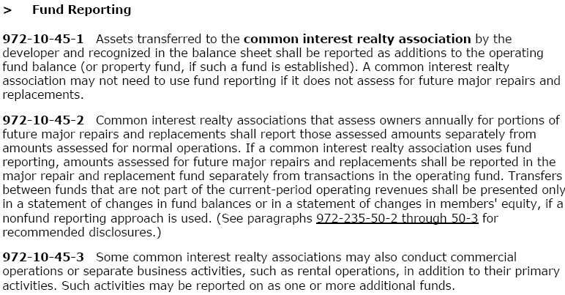

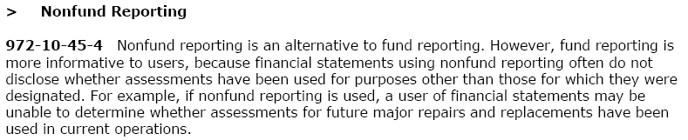

GAAP feels fund reporting is more informative

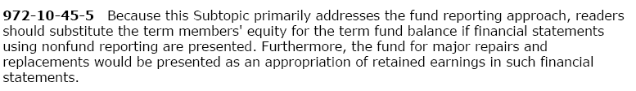

Note: that even if fund accounting is not used, replacement fund activity (reserves) should be presented as an appropriation of retained earnings.

The bottom line is that there is a segregation of operating and reserve activity.

Assessments for major repairs and replacements (reserves) must be reported separately from operations – based on the BUDGET.

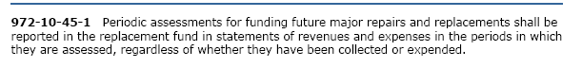

Footnotes as required:

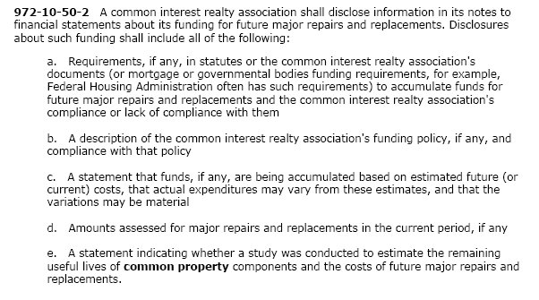

Required (unaudited) Supplemental Information:

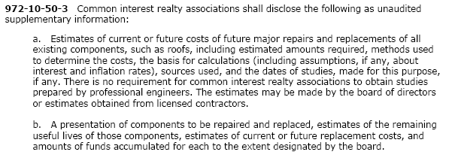

C:\Users\Gayle\AppData\Local\Microsoft\Windows\Temporary Internet Files\Content.IE5\1JDDSMBC\MC900233691[1].wmf

**RCW**

Condos:

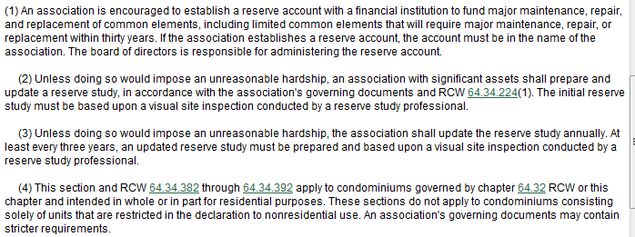

HOAs:

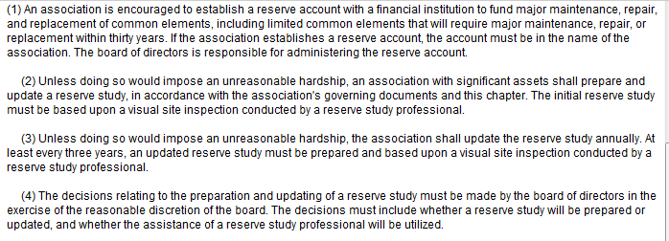

The Association is “encouraged” to set up a separate bank account for reserve activity. This implies (to me) a preference for segregated activity separate from operating fund.

**IRS**

**Form 1120-H** – No reserve requirements

**Form 1120** – STRICT requirements

* Segregation of operating and reserve cash
* Advance notification to membership
* Justification
* Use of monies as designated
* Capital purpose

**Revenue Ruling 70-604**

* Only relates to form 1120 (but it is a good “insurance policy” to have it approved every year)
* Has NOTHING to do with Reserves!
* It deals with transferring excess membership income to the next year
* After that has been done, a separate decision (not 70-604) can be made to transfer excess monies to the replacement fund.

**Industry Standards** 

“Reserves” is the term commonly used for the Fund for Major Repairs and Replacements.

Fund accounting is definitely the industry standard and Washington is also trending to fund accounting.

You want to be among the TOP…so if you are not looking at some form of fund accounting you should be!

**Why Fund Accounting?**

Our recommendation – fund accounting! Almost all computer programs can now prepare fund accounting statements in some form – either as separate balance sheets and income statements or in the columnar format. The benefits ~

* Know when reserve deposits are not made
* Know when expenses are paid out of the wrong fund
* Know when monies are borrowed or transferred between funds
* Have a usable operating fund net income statement that can be used as a comparative with the budget
* Better chance of catching errors or missing transactions that SHOULD be made – between funds
* Better information for the Board and management to make decisions

C:\Users\Gayle\AppData\Local\Microsoft\Windows\Temporary Internet Files\Content.IE5\DUWHEIHL\MC900233770[1].wmf

**Types of Funds**

**Operating**

Annual, operating type of income and expenses

**Replacement**

Future major repairs and replacements of common areas

**Insurance Reserve Fund - NOT**

Many documents require an “Insurance Reserve Fund” or similar wording. When monies are being set aside for insurance premium payments this is an operating function – not a reserve function. So, if you want this as a separate fund, it is a segregation of operating not reserves.

**Property Fund**

Some associations have significant property and wish to segregate these fixed assets into a separate fund. Seldom used, but is addressed and allowed per GAAP.

**Other – Special Project, Settlement, Special Assessment**

Discretionary. We highly recommend that separate funds be established when there is a specific purpose of receipt and use of monies.

**Due Between Funds**

When one fund owes another fund money. It can be a result of ~

* Reserve deposits not made
* Expenses not paid out of right fund
* Wrong amounts – either deposited or paid
* Wrong coding of expense
* Monies borrowed
* Interest not properly posted
* Accounting errors (e.g. journal entries

**Transfer Between Funds**

When one fund moves assets from one fund to another. It can be a result of ~

* Moving cash permanently between funds
* “Forgiving” loans or
* “Forgiving” amounts Due Between Funds
  + But like any asset and liability, they can be written off if not verifiable. For associations this is written off as a “transfer between funds” on the statement of changes in fund balance – not income statement.

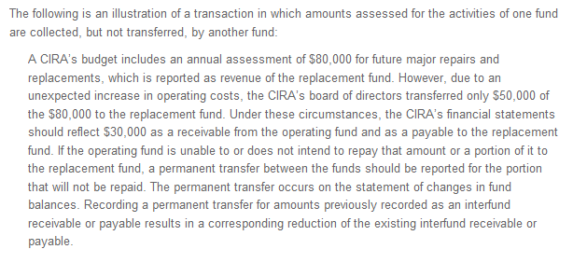

**Due Between Funds vs. Transfer – GAAP**

**Due Between Funds ~**

For GAAP –

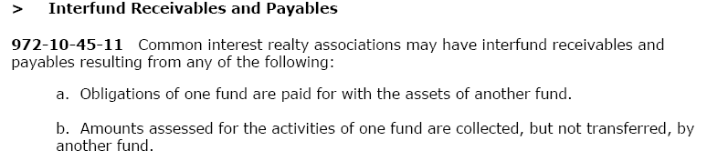



How to determine if it is a true receivable and payable?

* Intention?
  + Are there documented plans to repay?
    - Budget
    - Minutes/Resolution
  + New Reserve Study?
    - Starting with new cash balance
* Ability?
  + Enough operating cash/fund balance?

**Due Between Funds vs. Transfer - RCW**

What if budgeted reserve allocations do not occur – is it a loan? Is NOT funding the same as borrowing? One attorney went on record for one association and said for RCW purposes it was not a loan:

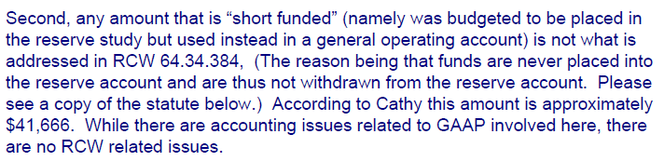

“True” Borrowing ~ RCW –

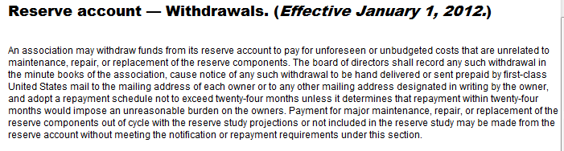

**Due Between Funds vs. Transfer – IRS**

**Form 1120 – H**

* No Impact

**Form 1120**

* May fail the test ~
  + Strict segregation of cash
  + Use of monies as intended
* Thus, if there are large Due Between Funds OR Transfers Between Funds often form 1120 is not a viable choice

**Balancing Reserves**

**Example #1**

* Not all reserve allocations were transferred during the year.
* Interest was earned on reserve cash and posted to reserve fund
* Expenses were coded to reserve expenses, but were paid out of operating cash.

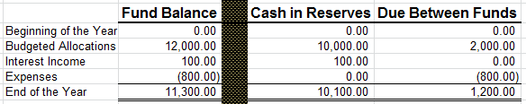

**Operating cash owes reserve cash $1,200.00**

**Example #2**

* You took over an Association and there was $30,000.00 shown as a shortfall between reserve cash and reserve fund balance.
* No reserve allocations were deposited during the year ($12,000)
* There was $10,000 borrowed due to the cash shortfall in operating.

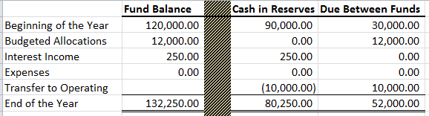

**Operating cash owes reserves $52,000**

**What is required to be repaid per GAAP? What should be recorded for RCW?**

**Does the IRS Care?**

**Assume that the Association has no excess operating monies, no plans to repay reserves and the Board will not increase assessments.**

**Controls on Reserve Activity**

**Funding in accordance with the Budget**

* Does your Board know when reserve deposits are missed?

**Reserve Expenses**

How to determine if it is a reserve expense or not?

GAAP –

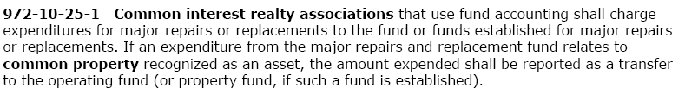

RCW – Reserve component definition

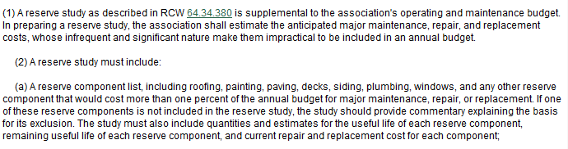

IRS – Must be “capital” in nature

Industry Standards - General indicators of reserve expenses (some or all may apply)~

* Major repair or replacement of a common area component that is not an annual event.
* Extends the life of a common area component.
* Included in the reserve study.
* Board determination.

We recommend that the Board meeting minutes record approval of all reserve expenses noting the vendor, the dollar amount and the fact that it is an approved reserve expense. This provides an audit trail at the end of the year and is a good internal control policy. Because this is a very subjective decision and because reserve monies are more strictly controlled, we want the Board to be very aware when monies are expended from reserve cash.

Each auditor will have different ideas as to what procedures are necessary to fulfill these requirements. There is little guidance in the CPA industry with regards to homeowner association audits. The American Institute of CPAs does publish periodic “Audit Risk Alerts” and this question was addressed in the 2000/01 edition as follows:

*“What might you (the CPA) consider when reviewing the minutes of your CIRA client?”*

*Replacement fund transactions. Minutes highlight replacement fund transactions, including replacement expenditures and other additions or subtractions to or from the fund. In addition, minutes reveal the approval of any replacement fund expenditures, accompanied by specific details related to the expenditure.*

On a related subject of internal control, the 1999/2000 edition stated the following:

*“…more than one board member should review and indicate approvals of requests for all major work to be performed by contractors to help eliminate the opportunity for noncompetitive bidding.”*

These would be considered as “industry standards” rather than GAAP. So is it REQUIRED to be in the minutes, from an auditor’s standpoint? No. It depends on what the individual accountant feels enhances their ability to determine the correctness of the financial statements and reduces the chance of fraud. I know from our firm’s standpoint that the minutes provide an audit trail and that both errors and fraud have been discovered when the minutes do not correlate with the actual expenditure.

**Integrating the Reserve Study into your Financial Decisions/Statements**

* Funding in agreement with Reserve Study
* Spending in agreement with Reserve Study

Changes in either not funding or not spending according to the Reserve Study can significantly impact future cash flow projections.

**So…do you now agree that Accounting for Associations is more fun than the CIRCUS???**

C:\Users\Gayle\AppData\Local\Microsoft\Windows\Temporary Internet Files\Content.IE5\1JDDSMBC\MC900360866[1].wmf