FUN Things

in

Accounting & Auditing

C:\Users\Gayle\AppData\Local\Microsoft\Windows\Temporary Internet Files\Content.IE5\3MJZIQZ9\MC900286937[1].wmf

**Managers Only Day**

**June 14, 2011**

**Presented by Gayle L. Cagianut, CPA**

**Cagianut & Company, CPA**

**C:\Users\Gayle\AppData\Local\Microsoft\Windows\Temporary Internet Files\Content.IE5\03Z8Z2KZ\MC900198791[1].wmf**

**C:\Users\Gayle\AppData\Local\Microsoft\Windows\Temporary Internet Files\Content.IE5\03Z8Z2KZ\MC900331555[1].wmfYou work your magic making sure that the Board understands their responsibility to read the financial statements ~**

**You balance the time you spend on association matters~**

**C:\Users\Gayle\AppData\Local\Microsoft\Windows\Temporary Internet Files\Content.IE5\1JDDSMBC\MC900233691[1].wmf**

**You tame the lions ~ who could be homeowners, Board members or auditors**

**(to name a few)**

**You jump through hoops for all!**

**C:\Users\Gayle\AppData\Local\Microsoft\Windows\Temporary Internet Files\Content.IE5\R936G207\MC900331546[1].wmf**

**You juggle an infinite number of jobs~**

C:\Users\Gayle\AppData\Local\Microsoft\Windows\Temporary Internet Files\Content.IE5\03Z8Z2KZ\MC900287577[1].wmf

**You walk a tightrope being a diplomat while ensuring professionalism**

**And to TOP it off…there is Accounting Fun, too!!**

C:\Users\Gayle\AppData\Local\Microsoft\Windows\Temporary Internet Files\Content.IE5\1JDDSMBC\MC900360866[1].wmf

**Who said the CIRCUS is the most fun around??? Dealing Associations is Entertainment Enough!!!**

**Resources for you to use:**

[www.hoacpa.com](http://www.hoacpa.com)

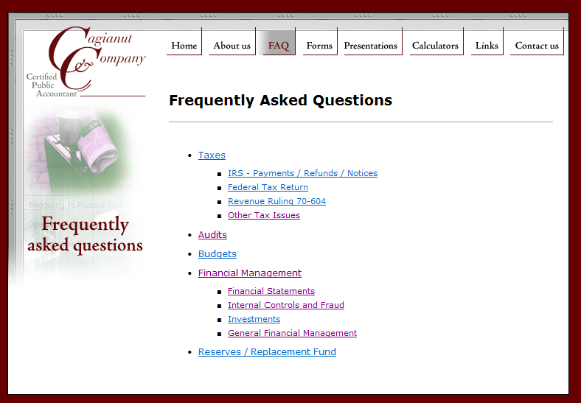

This presentation will also be on the website.

<http://cirawiki.aicpa.org/> Free site



<http://asc.fasb.org/home> Basic view is Free - GAAP

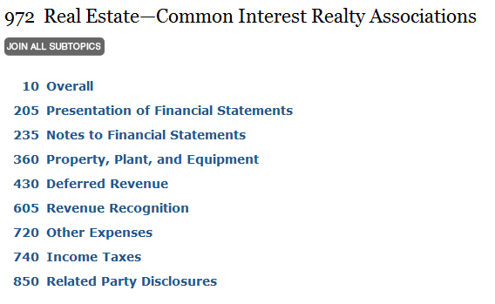

C:\Users\Gayle\AppData\Local\Microsoft\Windows\Temporary Internet Files\Content.IE5\R936G207\MC900237906[1].wmf**Bad Debt, Foreclosure & Collection Issues**

While bad debt write-offs and foreclosures have reduced in the last year or so, this is still a tough financial issue facing most Associations today. Associations are being split apart by assessments that are not paid, units that are abandoned and banks that won’t cooperate. Money is tight so bills cannot be paid and Boards are hesitant to raise assessments. Collection options are costly, but the Board must move forward. There are many accounting issues with regards to collections, bad debts and foreclosures.

**Accounting for Collection Costs**

While not required, our recommendations when asked ~

* Legal Fee income is billed directly to the unit owner as the Association is billed.
* Legal Fee income is in a separate income account OR in a Legal Fee Reimbursement Account (contra expense).
* Legal Fee expenses for collection matters is a separate expense account from general legal expenses
* Legal Fee Income and Legal Fee – Collection Expense should net to zero in the same accounting period.

*****************************************************************

C:\Users\Gayle\AppData\Local\Microsoft\Windows\Temporary Internet Files\Content.IE5\3MJZIQZ9\MC900054676[1].wmfHow are you recording legal fees billed for collection? Are you recording interest and other charges added to the unit owner account while at the attorneys for collection?

**Bad Debt Write-Off**

From an internal control standpoint, the Board should be aware of and approve any significant bad debt write-offs. If write-offs are approved based upon the attorney’s advice, then get that legal advice in writing.

For bad debt write offs – be sure and give adequate detail. This internal control procedure is important for the Board, manager and auditor.

Other Bad Debt Write-Off Considerations/Options ~

* Writing off against current year other income is appropriate, at times.
* Writing off against reserves may be appropriate, at times
* Bad debt recovery income should first be offset against bad debt expense

*****************************************************************

C:\Users\Gayle\AppData\Local\Microsoft\Windows\Temporary Internet Files\Content.IE5\3MJZIQZ9\MC900054676[1].wmfWhat kind of approval or documentation does your accounting department get before an account is written off to bad debts?

**Allowance for Bad Debts**

We were very impressed that many more associations are including bad debt allowances on the year-end financial statements. An allowance for bad debts is very important because ~

* It is required by GAAP
* It ensures that the assets of the Association are not overstated
* It shows that the Board and manager are actively managing the Association and are aware of the potential for uncollectible accounts
* It gives a better financial picture for cash flow management and future budgeting.

We generally recommend that an allowance be determined by individual unit owner accounts. You will find that we often ask you how collectible a list of very delinquent accounts are using these three standards:

* 100% Collectible – no allowance needed
* Probably/Possibly Collectible – 50% allowance
* Uncollectible – 100% allowance (less 6 months assessments for condos)

Alternately, you could use a percentage of assessments or a percentage of past due at 60 days, 90 days, and/or 120 days, or give actual known/estimated amounts by account.

We, as auditors, need to be able to give an opinion that the allowance estimate is reasonable. Be prepared to defend it!

These are the Board’s financial statements. They need to be aware of the bad debt allowance and they should approve of this adjustment.

**************************************************************

C:\Users\Gayle\AppData\Local\Microsoft\Windows\Temporary Internet Files\Content.IE5\3MJZIQZ9\MC900054676[1].wmfHow are you getting the bad debt allowance number? How are you giving that information to your accounting department?

**Recording Foreclosures/Sheriff’s Sale**

There are more questions than answers with regards to accounting for foreclosed units and there is little in the way of absolutely accounting guidance. Below are some questions that were raised and our recommendations:

What needs to be recorded on the financial statements with regards to foreclosed units?

In most cases the Association does not have an asset of value. The unit is still subject to a mortgage that most likely exceeds the fair market value of the unit. GAAP states that the FMV must be used to record the asset. GAAP also states that the mortgage cannot be included on the financial statements because it is not an obligation of the Association. Thus, there may need to be a reduction in value as the asset is “impaired”. In my opinion, often the “true” value is zero.

IF the Association obtains title on a unit with equity, then this equity would be an asset to the association if there is no redemption period or other way for another party to take possession of the unit.

What about monthly assessments foreclosed units?

It is our recommendation that the monthly assessments continue to be recorded per the budget for all units – even the foreclosed unit. Then the Association can expense the nonpayment of the assessment.

What about when the Association decides to rent out a foreclosed unit?

Most importantly, this is a legal question. The Board and management should obtain legal advice on this matter.

From an accounting standpoint, be sure and segregate rental income and all costs associated with the rental of the unit – insurance, repairs, utilities, etc. The rental income will be taxable so it is easiest if you set up your account categories from the beginning to capture these costs.

What about monies received from a bank to clear the title?

We have had several instances this audit season where the Association has received monies from the bank to clear the title and release the unit to the mortgage holder. These monies are above and beyond any costs or write-offs of assessments balances. In these cases, the net proceeds (after expenses) are taxable.

What if an Association truly obtains a unit with equity and makes a profit selling the unit?

Whether the net gain is taxable will need to be discussed with the Association’s tax preparer. In very limited circumstances, with the approval and understanding of the Board it may be possible for the income to be membership income and potentially non-taxable. In general, however, the net gain would be taxable to the Association.

Here is a sample footnote in an audit when there is a Sheriff’s Sale:

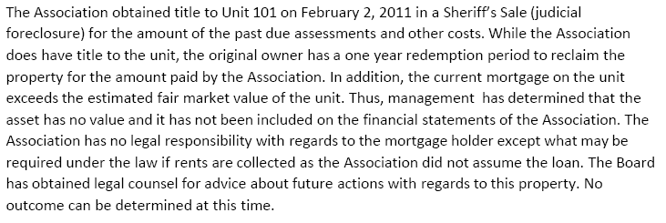

****************************************************************

C:\Users\Gayle\AppData\Local\Microsoft\Windows\Temporary Internet Files\Content.IE5\3MJZIQZ9\MC900054676[1].wmfHow do you document and segregate costs on foreclosed units?

**Special Assessment Accounting**

Similar to this picture, there are many things that can go wrong with regards to accounting for special assessments – depending on the payment terms and other considerations. One misstep and everything gets out of balance.

**Special Assessments with Payment Terms**

Special Assessment #1

There is a special assessment of $1,200 payable at the rate of $100 per month for twelve months.

Special Assessment #2

There is another special assessment of $100 a month for twelve months.

What is the correct way to book either assessment?

Accountants do not agree and the American Institute of CPAs will not take a position on the matter. The options would be:

Book the AR of $1,200 at the onset with $1,200 to special assessment income.

OR

Book $100 per month to AR and special assessment income.

Absent differing legal advice, we recommend recording the $1,200 (the full special assessment when assessed). **GAAP allows both methods.**

**Special Assessments with Payment Terms Including Interest or Financing Fee (or Discount)**

Special Assessment #3

There is a special assessment of $1,200 payable at the rate of $100 per month for twelve months or the unit owner can make one payment of $1,100 now. What is the correct way of recording the assessment?

Options:

* Record the $1,200 and an offsetting $100 discount for those that pay in advance
* Record $1,200 for those making payments and $1,100 for those paying in full
* Record $1,100 for those that pay in advance and book $100 per month for everyone else.

We recommend recording the $1,200 and using a discount account for the $100.

Special Assessment #4

There is another special assessment of $1,200 due now or the unit owner can make payments of $105.50 per month (computed with an interest rate of 10%) each month.

Options:

* Record the $1,200 and book interest each month for those making payments
* Record $1,200 for those that pay in advance and book $105.50 per month for everyone else.
* Record $1,305.50 for everyone and when the pay in advance or show a discount of $105.50

We recommend recording the $1,200 for all and monthly interest per the amortization schedule. This can get complex in an association with variable assessments. Unit owners may make extra payment requiring a separate amortization schedule for almost every unit making payments. **GAAP allows the method of your choice – with proper disclosure.**

**Special Assessment Accounting ISSUES**

Amortization Schedules

When interest is charged on a special assessment and there are varying amounts of the special assessment (depending on ownership percentage, for example), then separate amortization schedules must be maintained for each special assessment.

When unit owners choose to pay more or less than the set monthly fee, their individual amortization schedule must be adjusted accordingly.

No computer software used by Associations is able to process these individual amortization schedules. Thus, this is a separate effort by the accounting department.

When the Special Assessment is Tied to a Loan

There can be a timing issue with regards to the beginning of the loan and the beginning of the special assessment. These may not coincide. Or, the loan may be an interest only construction loan until it converts to a regular amortized loan. These timing issues may result in differences of interest rates or differences in the amount of the loan payment versus the special assessment income.

When a unit pays off their portion of the special assessment, their interest stops. Thus, that payoff should be immediately applied to the loan to stop the interest on the loan. There needs to be procedure in place to ensure that these monies are not inadvertently kept in the bank account and used for operating expenses.

When the payoffs of special assessments occur, the amount of special assessment income is now less than the amount of the loan payment. If enough members payoff, this difference can be significant. The loan may need to be re-amortized. Some loan documents only allow a specific number of re-amortizations or after a certain period of time.

******************************************************************

C:\Users\Gayle\AppData\Local\Microsoft\Windows\Temporary Internet Files\Content.IE5\3MJZIQZ9\MC900054676[1].wmf What does your firm do for special assessments with payment terms?

C:\Users\Gayle\AppData\Local\Microsoft\Windows\Temporary Internet Files\Content.IE5\3MJZIQZ9\MC900054676[1].wmfHow do you track balances owed at time of escrow if the full amount is not on the books?

C:\Users\Gayle\AppData\Local\Microsoft\Windows\Temporary Internet Files\Content.IE5\3MJZIQZ9\MC900054676[1].wmf

Do you ensure that you involve your accounting department in this process and make proper consideration of the additional time and effort when agreeing to this? Is a sufficient fee being charged?

**MORE Special Assessment Accounting ISSUES**

**Deferred Income**

In accordance with GAAP (FASB Codification) for Common Interest Realty Associations ~

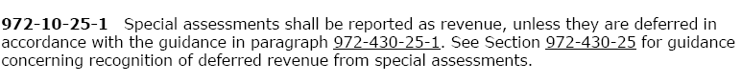

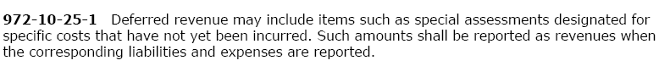

Thus, special assessments are generally recognized as revenue unless they are “designated for specific costs” at which time the unexpended amounts must be deferred. Accounting needs to know the purpose of the special assessment to properly capture the costs.

**Special Assessments – Use of Third Fund**

If the special assessments are large enough, last for more than one year and are specific in purpose, we recommend the use of a third fund. If a third fund is used, then we do not feel that deferred income is necessary.

*****************************************************************

C:\Users\Gayle\AppData\Local\Microsoft\Windows\Temporary Internet Files\Content.IE5\3MJZIQZ9\MC900054676[1].wmfDo you document the specific uses for the special assessment and how any excess monies will be handled?

C:\Users\Gayle\AppData\Local\Microsoft\Windows\Temporary Internet Files\Content.IE5\3MJZIQZ9\MC900054676[1].wmf

Do you discuss with the Board and your accounting department if a separate fund is appropriate (if you have the ability to set up funds)?

C:\Users\Gayle\AppData\Local\Microsoft\Windows\Temporary Internet Files\Content.IE5\3MJZIQZ9\MC900331556[1].wmf**Controls on Other Income**

Strong internal controls are needed on income items that are not able to be verified via other means (e.g. assessments agree with budget, special assessment agree with Board resolution, insurance claim and settlement income agrees with claim check and settlement document). Types of other income requiring internal controls include move in/out fee, guest suite fees and clubhouse rental fees – to name a few.

Internal controls require that at least two separate people be involved in the process and that an independent reconciliation be performed. With other income we are auditing what is NOT there more than what IS there. Thus, we are concerned about monies that may not show up due to error or fraud. In most of these cases analytical procedures – comparison with budget and/or prior year - is not a complete enough indicator.

Below are some examples of controls that could be used for Move In/Out Fees. Not all of these are required or appropriate at all times, but each Association would have a policy as to which to use.

* Person A makes the deposit with the list of names. Person B keeps a list of changes that are associated with move in/out fees (e.g name changes in the billing system, new gate cards, changes in owners list in lobby, etc.) . These may indicate new owners or tenants. Person B reconciles the name change list with the deposit list.
* Person A makes the deposit with the list of names. Person B keeps a list of the resale certificates and new rental leases. Person B reconciles these lists with the deposit list.
* Person A makes the deposit with the list of name. Person B sends out welcome packets to new move-ins. These are reconciled.

Below are some examples of controls that could be used for Guest Suite Fees and other rental type of income:

* Person A maintains a calendar of usage or reservation log. Person B collects the money and makes the deposit or gives to someone to make the deposit. Person A (or C) compares the calendar with the actual deposit.
* If there is an expense that is associated with usage (e.g. maid services after each use of the guest suite) the expense is compared with the income. For example if the maid cleaned 8 times in the month there should be 8 rental fees.

Other internal controls that do not reconcile the income with an independent means, but they provide some assurance that income is complete and accurate are as follows:

* Random testing of the transaction.
  + Periodically checking the calendar against actual usage – unannounced visits to the guest suite or check-in desk
* Approval/verification of the Board.

************************************************************

C:\Users\Gayle\AppData\Local\Microsoft\Windows\Temporary Internet Files\Content.IE5\3MJZIQZ9\MC900054676[1].wmfWhat types of income do you have that require these types of controls?

C:\Users\Gayle\AppData\Local\Microsoft\Windows\Temporary Internet Files\Content.IE5\3MJZIQZ9\MC900054676[1].wmfWhat controls can you implement?

C:\Users\Gayle\AppData\Local\Microsoft\Windows\Temporary Internet Files\Content.IE5\03Z8Z2KZ\MC900237931[1].wmf **Audit Process**

This is probably you wanting to throw knives at us during the audit process. ☺ We try and not be too intrusive, but it is our job to make sure that the financial statements are materially correct and in compliance with GAAP. We must document our procedures and the type of verification we used. Each auditing firm uses their own judgment on “what is enough”. What is it that we would like you to know about the audit process?

**Independence**

An auditor must be “independent” to issue an opinion on the financial statements. This concept of independence has many facets, but one is that we cannot audit our own work. We must be independent of the decision making process that produced the financial statements. Thus, we cannot be bookkeepers or accountants for the Association and maintain our independence. We are able to post standard journal entries, propose certain journal entries for errors found within the audit, and assist in the drafting of the financial statements. But, we are not to perform the actual work or make management decisions. Thus, the financial statements should come to the auditor with the banks balanced, the accounts reconciled and any accounting work completed prior to the audit.

Additionally, please know that all auditors have to approach the audit with “an attitude of skepticism”. We are charged with looking for fraud and designing the audit accordingly. Thus, we must maintain our independence from the manager. We appreciate you, we value your professionalism, and we can be friendly and enjoy normal communications and relationships. However, we cannot let even the appearance of lack of independence creep into the relationship. We must maintain some distance.

A final reminder – the Association is our client….not the manager. There are times when we need to deal directly with the Board and while there are appropriate ways to do so and to communicate those dealings to the manager, if we are expressly directed by the Board in a matter that must be our first allegiance.

******************************************************************

C:\Users\Gayle\AppData\Local\Microsoft\Windows\Temporary Internet Files\Content.IE5\3MJZIQZ9\MC900054676[1].wmfWhat reconciliations and adjustments do you need to make for the financial statement to be “audit ready”?

C:\Users\Gayle\AppData\Local\Microsoft\Windows\Temporary Internet Files\Content.IE5\3MJZIQZ9\MC900054676[1].wmfWhat can you do to ensure that you have a professional and friendly relationship with the CPA without the appearance of lack of independence?

**Client Representations**

The financial statements are the clients. They are not ours. It is a requirement that the client “represents” certain understandings and facts to us at the end of the audit. It is a requirement that we receive those client representation letters back signed by the appropriate people.

When we receive the signed representation letters, this is our signal that the audit has been approved/accepted and the final report is ready to go out. By auditing standards, we cannot make changes to the audit workpapers or reports more than 60 days after the date of the draft report. Any changes after that date require additional audit work. Thus, the manager can assist by ensuring that the audit is reviewed, accepted and/or any changes are given to the auditor within that 60 day period.

Sometimes the current Board does not want to sign for a past Board’s actions. The standards say that the Board that has responsibility at the time the audit is issued must sign the representation letter. If they have serious concerns about certain matters, those should be expressed to the auditor. The representation letter clearly states that the Board is making assertions “to the best of their knowledge”. If the Board will not sign the letter, the audit opinion will have a scope limitation.

In our firm we require the manager, president and treasurer to sign the representation letter. That is common industry-wide. Other CPAs may have different requirements.

*******************************************************************

C:\Users\Gayle\AppData\Local\Microsoft\Windows\Temporary Internet Files\Content.IE5\3MJZIQZ9\MC900054676[1].wmfWhat can you do to ensure that the Representation Letters are signed in a timely manner?

**Adjusting Journal Entries – Why should you care?**

The year-end financial statements, as adjusted, are the GAAP-prepared, full accrual, “official” financial statements of the Association. The Board and manager should understand the adjustments that were made. There should be consideration as to whether these adjustments should be recorded on the books of the Association.

Additionally, the Board should determine if the corrections are due to errors in accounting procedures and/or financial statement presentation. If so, the internal processes or financial statements should be changed accordingly.

**Reading the audit report**

This could be a whole class by itself, but here are two hints ~

1. **Read the Footnotes**

They should tell you important things about the numbers on the financial statements, about the Association, the accounting policies and procedures and about items that may have a financial impact that are not currently on the financial statements (e.g. litigation, foreclosed units, etc.).

1. **Look at the Operating Fund – What is the Association’s Net Worth?**

We recommend 1-3 months of operating expenses to be the balance in the Operating Fund. This allows a “cushion” for contingencies and unexpected cash flow requirements.

**Report of Internal Controls**

Generally accepted auditing standards (GAAS) require that auditors consider internal controls during the audit process. Any deficiencies noted must be communicated to the Board of Directors in a Report of Internal Control.

Whenever an auditor prepares a journal entry, the auditor must consider whether there was a control deficiency. Unless the AJE is for a basic, accrual adjustment, generally a deficiency usually exists. The supposition is that no adjustment would have been needed if proper controls were in place.

Additionally, when documentation cannot be found, when processes don’t allow for segregation of duties and a myriad of other items found during the audit process require the audit to include a point in the Report of Internal Controls.

Two levels of deficiencies:

* Significant Deficiency (the lessor of the two)
* Material Weakness

The auditor must choose the appropriate category for the internal control deficiency.

This report is to be used to assist the management company and/or Association to strengthen internal controls.

*************************************************************************

C:\Users\Gayle\AppData\Local\Microsoft\Windows\Temporary Internet Files\Content.IE5\3MJZIQZ9\MC900054676[1].wmfWhat can you do to help your Boards understand the Audit Report, adjustments and Report of Internal Control better?

**So…do you now agree that Accounting & Auditing of Associations is more FUN than the CIRCUS???**

C:\Users\Gayle\AppData\Local\Microsoft\Windows\Temporary Internet Files\Content.IE5\1JDDSMBC\MC900360866[1].wmf