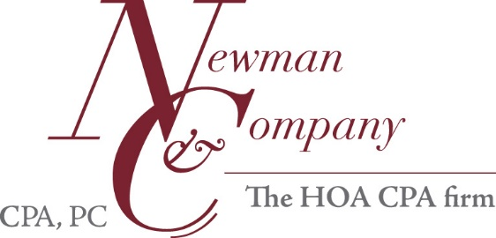
Manager-Records Request List—12/31/17 Audit-Returning Client
Please send all information in electronic format whenever possible.
A drop box is available for large or multiple documents.
Please contact us if a drop box is wanted at info@hoacpa.com.

- Member-Ratified Final Budget (the copy from the member budget meeting)
  - Next Year (include assessments/unit listing) 2018

- Insurance
  - Declaration/Policy Pages showing policy dates 2017-2018

- Reserve Study-Final Board Approved
  - Most Recent
OR
  - No Reserve Study

- Minutes
  - Board of Directors and Executive Session Minutes-Audit Year 2017
  - Board of Directors, Executive Session and Membership Minutes - 2018
Next Year
Drafts okay as necessary.
  - Membership Minutes-Audit Year 2017
  - Budget Ratification Meeting Minutes and Budget Packet 2017
Drafts okay as necessary.
We must collect minutes for every meeting held; if minutes do not note meeting
schedule, please provide a meeting calendar.

- Other
  - Bad Debt Allowance Estimation
All accounts with balance over 6 months assessments
  - Legal matters (other than collections), please explain and note attorney name ______________________________________________________
  - Current Board Roster

