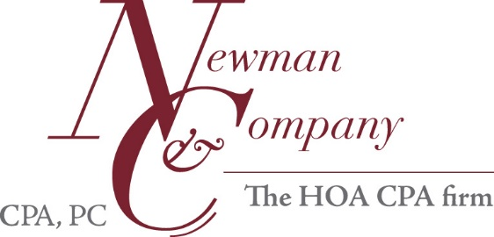
Manager -Records Request List—12/31/17 Audit-New Client
Please send all information in electronic format whenever possible.
A drop box is available for large or multiple documents.
Please contact us if a drop box is wanted at info@hoacpa.com.
- Governing & Other Documents
  - Articles of Incorporation
  - Bylaws
  - Declaration (CC&Rs)
- Prior-Year Documents
  - Prior-Year Tax Return 2016
  - Prior-Year Audit, if any 2016
Name of prior-year auditor____________________________________
- Member-Ratified Final Budgets(the copy from the member budget meeting)
  - Audit Year (include assessments/unit listing) 2017
  - Next Year (include assessments/unit listing) 2018
- Insurance
  - Declaration/Policy Pages showing policy dates 2016-2017
  - Declaration/Policy Pages showing policy dates 2017-2018
- Reserve Study-Final Board Approved
  - Most Recent
OR
  - No Reserve Study
- Minutes
  - Board of Directors and Executive Session Minutes-Audit Year 2017
  - Board of Directors, Executive Session and Membership Minutes- 2018
Next Year- Drafts okay as necessary.
  - Annual Membership Minutes-Audit Year 2017
  - Budget Ratification Meeting Minutes and Budget Packet- 2017
Drafts okay as necessary.
We must collect minutes for every meeting held; if minutes do not note
meeting schedule, please provide a meeting calendar.
- Other
  - Bad Debt Allowance Estimation
All accounts with balance over 6 months assessments
  - Legal matters (other than collections), please explain and note attorney name ______________________________________________________
  - Current Board Roster

